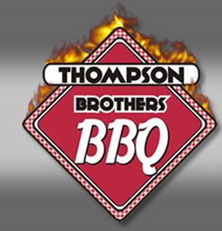
MKT 301 Principals of Marketing Winter Final project
Background
Five brothers named Thompson originally from Tulsa, Oklahoma had a dream to someday own a family owned business using down home recipes passed down through the family. Following the brothers graduation from higher education in a variety of fields of business, a restaurant was founded in Smyrna, GA affectionately named Thompson Brothers BBQ.
Brother Carroll, carried out the plan and is the ever-present member whose constant attention to detail results in a high level of customer satisfaction. Corey brought valuable management skills, culinary experience and the unforgettable down-home recipes. Carroll and Corey control all day-to-day operations.
Thompson Brothers BBQ located at 2445 Cobb Parkway, Smyrna, GA 30080 has received numerous awards for their outstanding culinary expertise in smoked BBQ and their contributions to various community organizations.
With the growth of the metropolitan area as a vital part of the vibrant development of the southeastern region and several multinationals moving into the area taking advantage of the tax breaks and affordable housing, quality restaurants are needed to nourish the influx of person’s moving to the area.
In addition, world-class studios Pinewood Studios, Fayetteville, GA and Tyler Perry Productions (occupying Ft. McPhearson) built for the production of film, television, music and video. Are/will be full service film and entertainment studio complexes comprised of sound stages on 100’s of acres in Fayetteville, Georgia and Ft. Mac, just south of Atlanta.
This might be a great opportunity for Thompson Brothers BBQ to expand their business as they fulfill a vital role of down home delicacies to a new group of people moving to the metropolitan area.

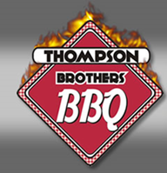
Final Assignment
Research the metropolitan area to pinpoint a viable location to expand the business and write a fully integrated marketing plan. Leveraging text book philosophies, concepts and theories, perform extensive research on the current and future Atlanta economy and the anticipated business growth strategies. As a part of your research, include visiting the proposed areas of the greater metropolitan Atlanta area and perform a site visit on the current restaurant. The marketing plan should include the following;
- Executive Summary
- Business plan
  - Create a value proposition
  - SWOT analysis
- Market Research
  - Evaluate the internal & external environment
- Organizational objectives
- Development of growth strategies
- Deliver the plan
You will be divided into 3 groups
- Research Team
- Creative Team
- Proposal Team
Although you will be separated by specialty (team) you are all expected to work together. This serves as a real-life assimilation of how work of this magnitude is done as any major corporation. Feel free to use whatever tools needed to present this plan to include my support, resources from TBBBQ, ask the owner and by all means, visit the restaurant. Creativity is encouraged.
As a part of your final exam, in week 11, you are responsible to deliver a fully integrated marketing presentation to the owners of TBBBQ and invited guest from the Life University staff.
I am here to help you as you progress through this community based project. The weekly assignments will assist you as you proceed through this project.
You will be graded using the Life University rubric.

